Project Design Phase-II
Data Flow Diagram & User Stories

Date | 27-12-2025
Team ID | SmartBridge – MERN stack batch 5497
Project Name | DocSpot

Data Flow Diagrams:
A Data Flow Diagram (DFD) illustrates how data moves within the Freelance Finder platform. It captures how users (freelancers and clients) interact with the system, how information flows between different components, and where the data is stored.
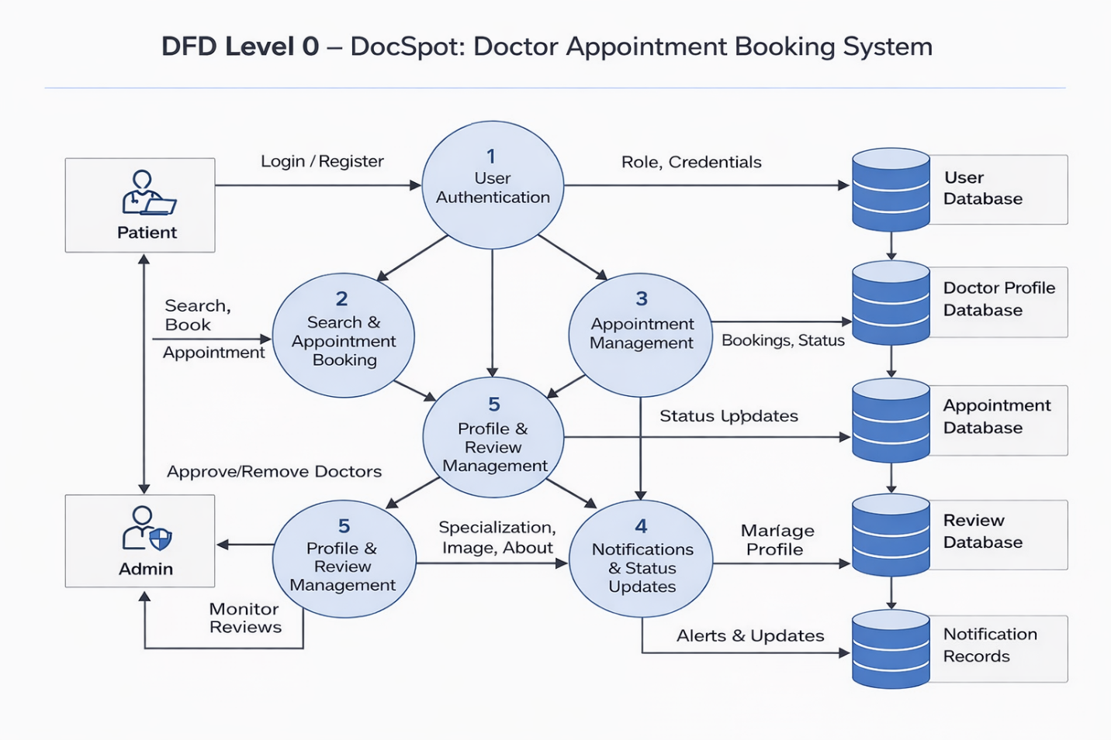

User Stories – DocSpot

User Story Table – DocSpot
User Type | Functional Requirement (Epic) | User Story / Task | Acceptance Criteria | Priority | Release
Patient | User Registration & Login | As a patient, I can register and log in securely. | Patient account is created and user is redirected to dashboard after login. | High | Sprint-1
Patient | Doctor Search | As a patient, I can search doctors by name or specialization. | Search results display relevant doctors based on input. | High | Sprint-1
Patient | Appointment Booking | As a patient, I can book an appointment with a doctor by selecting date and time. | Appointment is saved and visible in patient dashboard. | High | Sprint-1
Patient | Appointment Details | As a patient, I can provide age, phone number, issue description, and preferred timing while booking. | Details are stored and shown to the doctor. | Medium | Sprint-2
Doctor | Appointment Management | As a doctor, I can view all appointment requests from patients. | Appointment list is displayed in doctor dashboard. | High | Sprint-1
Doctor | Appointment Approval | As a doctor, I can approve or reject appointment requests. | Appointment status updates and patient is notified. | High | Sprint-1
Patient | Appointment Tracking | As a patient, I can view appointment status (pending/approved/cancelled). | Status updates correctly reflect doctor actions. | Medium | Sprint-2
Patient | Review System | As a patient, I can submit a rating and review for a doctor after consultation. | Review is saved and visible on doctor profile. | Medium | Sprint-2
Doctor | Profile Management | As a doctor, I can update my profile details like specialization, image, and description. | Profile changes are saved and visible to patients. | Medium | Sprint-2
Admin | Doctor Approval | As an admin, I can approve or reject doctor registrations. | Only approved doctors appear in public listings. | High | Sprint-1
Admin | Doctor Management | As an admin, I can remove doctors from the system if required. | Doctor is removed and no longer visible to users. | High | Sprint-2
Admin | Review Monitoring | As an admin, I can monitor doctor reviews to ensure platform quality. | Reviews are visible to admin for moderation. | Medium | Sprint-2
User | Logout | As a logged-in user, I can securely log out of the application. | Session is cleared and user is redirected to home page. | Medium | Sprint-1

